**Name –** Nalawade Prafulla Chandrashekhar.

**Class –** BE Artificial Intelligence and Data Science.

# Roll No. – 42

**Practical No. 02 -** Write an Arduino program for interfacing with PIR sensor Experiment.

# Circuit Diagram –

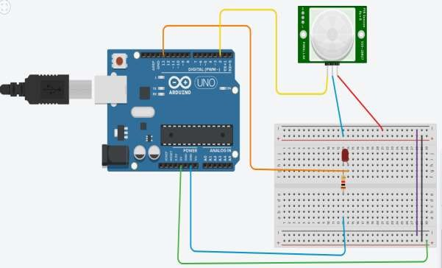

**Source Code –**

// Define pin numbers

const int pirPin = 2; // PIR sensor input pin

const int ledPin = 13; // LED output pin (built-in on many Arduino boards)

void setup() {

pinMode(pirPin, INPUT); // Set PIR pin as input pinMode(ledPin, OUTPUT); // Set LED pin as output

Serial.begin(9600); // Initialize serial communication for debugging

}

void loop() {

int pirState = digitalRead(pirPin); // Read PIR sensor state

if (pirState == HIGH) { // If motion is detected digitalWrite(ledPin, HIGH); // Turn on LED Serial.println("Motion detected!");

} else {

digitalWrite(ledPin, LOW); // Turn off LED Serial.println("No motion");

}

delay(1000); // Wait for a second before rechecking

}

# Output –

Motion detected.